In vladimir, on the wall of The DmitrievSky Cathedral, in ancient times, a dog-bird was painted and an inscription was made. An inscription that will shed light on all our relationships with dogs dear to our hearts. According to Russian popular belief, the dog was given to a man to "bring it to the People", i.e. to teach the unselfish feeling of love.
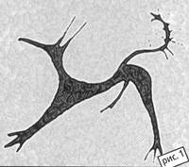
“Love is the main thing in the spiritual evolution of man.
After such words, everything falls into place, t. K. each of us, evil and good, treacherous and simpleton, stupid and intelligent, needs the selfless love that our pets give us. Whether it is sighthounds or, some, other dogs that many centuries ago accompanied us through life, accompany and will accompany as long as life exists on our planet. “
Almost-every nation has pride in creating some kind of breed ofdog.. Our pride is a Russian dog sighthound.. This dog is the embodiment of Russian culture, its centuries-old history.. Data on sighthound-like dogsaccompanying peoplewho inhabited the territory of modern Russiagoes far back centuries.. After the October Revolution, this breed was to be destroyed on a par with the legacy left by tsarism.. Russian dog sighthound shot because of-hatred for thenoble estate. But, having passed through these thorns, side by side with the Russian people, the breed has suffered all the further hardships of wars, famine, it has withstood in the besieged Leningrad, thanks to the self-denial, unparalleled and huge love of people to it.. And how much of the cultural heritage left to us by ancestors remained with us, in order to please us with its beauty and uniqueness..
The divine perfection of this dog has been honed for centuries. She is graceful, calm and majestic in the home environment.. Her eyes are infinitely expressive and deep. It seems that they have absorbed the entire history of centuries, and, as if, with the many faceth, silent knowledge, presented to them by nature, contemplate everything that happens around them.. They are wise, intelligent, sophisticated in their perception of the world and loyal..
At the same time, the condition of this dog is sharply contrasted at home and in the field, where its hunting instinct wakes up and it turns into a rapid, sharp, gambling, ieminable and unbridled dog.. I often compare the character of this dog with the character of a Russian man. This is a true aristocrat, for the external calm and upbringing of which slumbers mighty passion and excitement, accumulated and anchored by nature, as well as centuries-old traditions of mankind..
Hunting with a sighthound is as unique as the breed itself. It's the only hunting dog that doesn't require a nataski, t.. e. special training before hunting.. There are no unders holes in sighthound hunting and this is its clear advantage.

A bit of history
All dog breeding began with hunting, further hunting dog breeding and hunting dog shows.
The man tamed the dog - from this it all began...!!!
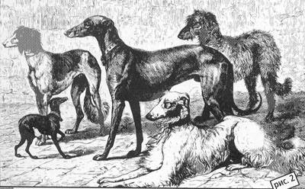
Surprisingly few notes, books, articles devoted to sighthounds and dog hunting have survived to this day. Dog hunting and keeping sighthounds was a privileged matter, and in the old days belonged mainly to the upper class - the nobility.
If we touch on the question of where the sighthound came from in the first place, then perhaps no one can say for sure. But the fact that this is one of the first dogs that lived next to people, no one doubts. Even in the Stone Age, a person was accompanied to hunt by a dog very similar to a sighthound, as evidenced by rock paintings, in the Sahara Mountain range, near the Tibetan mountains, approximately in the period from 12,000 to 6,000 thousand years BC. A. - however, no one knows where this dog came from.
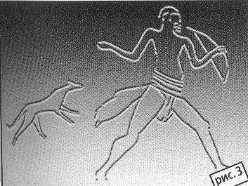
There is no doubt, however, that the dogs that caught up and caught the beast existed for a long time.. They certainly absolutely could not go unnoticed by humans, which reflected in the fact that the dog became one of the first domesticated animals. All this is confirmed by numerous excavations, architectural monuments and still-preserved sketchy records.. In all the pictures that have survived to this day it is clearly seen that the dogs accompanied the man on the hunt, that they were catching up and catching the beast, they were the necessary helper for him, which he really needed..
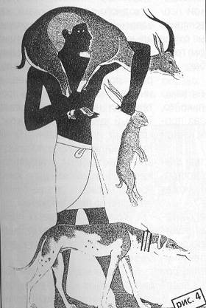
An image of a dog remarkably similar to a sighthound was found on the wall of the Pyramid of Cheops or Kufu /4235-3733. . up to R.. ХH./. The dog is depicted under its owner’s chair. According to the records that have survived to this day, Kufu was an excellent athlete and hunter.. He had a properly organized hunt and a lot of dogs. Proof of the strong type of sighthound dog that has developed already in those days is that to this day their distinctive features inherent in antiquity have been preserved..

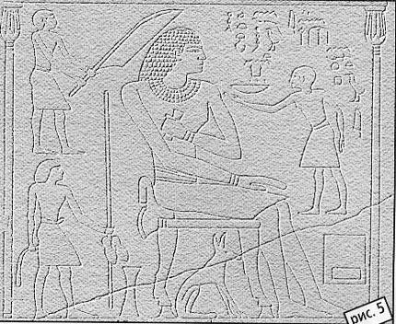
In Figure 5, we see King Antefa of Ancient Egypt, a famous hunter, again with a dog under a chair. The image dates from 2600. B.C. Heh.
Figure 6 dated 2500 B.C. On the wall of the stone tomb of Beni-Hazan, a sighthound is depicted, surprisingly reminiscent of a modern one. She wears a special collar around her neck with a ring at the top (apparently for the pack).
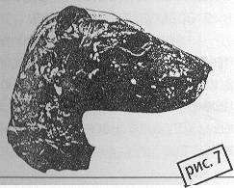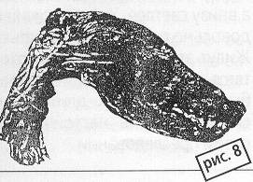
The 7th and 8th drawings show photographs of the mummy of the sighthound's head intact, and after removing the protective shells.. Mummies date back to about 1300 B.C.
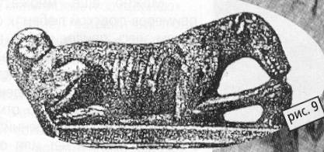
The following, 9 figure depicts a sighthound sculpture dating back to 550 AD. B.C. Heh. On it you can see that during this period the ears have changed, which are already half hung.
The same position of the ears of the Greek sculpture on the bronze lightbulb, dating from the 1V century to R.. H..
In general, Egyptian culture has preserved to this day a large number of sculptures, drawings and records about dogs of that time..
Yet the drawings and photographs shown here were taken from items stored in the British Museum..
In ancient times, dogs were revered. In the Egyptians, according to Diodor of Sicily, the head of the dog decorated the idol of Anubis in the temple of Isis and Oziris, and revered as a deity..
At all times dogs were loved and appreciated. In ancient times, beloved dogs were burned together with the deceased owner..
InSaint-Denis, in France, stone lions lie in the legs of the buried French kings.. The tombs of the queens stand on two dogs..
The mausoleum of FranzP, Duke of Brittany, stored in Nantes, in the cathedral, is decorated with a statue of a sighthound dog..
Frederick the Great in front of his palace in Sansushi has placed 8 monuments to his beloved dogs.
Empress Ekaterina P erected a monument to the dog "Semir" with a large inscription of Segur's composition..
There are many more examples of human love for dogs here, but let's get to the heart of my story.
Referring to the foreseeable historical period of the birth of sighthounds in Russia, it can be noted that archival information about it is almost non-existent or they are very rare..
There are many reasons for this. Religion has always been strong in Russia.. The Orthodox Church considered the dog "a dog snouthing", t.. e. animals impure, which could not even enter the threshold of an apartment building.. Most of the population, in those distant times, was illiterate.. But, stil, though sketchy, but the information about the "dogs" used in the extraction of the beast, can be found in those, then in other notes, which have reached the present days through the centuries.
Some information can be found in foreign authors who unwittingly witnessed the birth of a Russian sighthound. They were not shy to describe traditional hunting with dogs in the Russian state, and dogs themselves, religion allowed them..
Much is hidden from us for centuries, but surely only that the Russian sighthound originated from the mixing with the eastern sighthound..
But, with confidence to say from whom the eastern sighthound originated, again, no one can..
It is obvious, however, that the sighthound was born not in the forests, but in the open spaces, as indicated by the lack of flair and keen eyesight. Therefore, their homeland can be considered North Africa and West Asia. In Central Africa - Sudan, there was also a large dog, with a stiff coat, resembling a sighthound in the frets, quite similar to the sighthounds of the first pharaohs. Someone the place of her birth suggests North Africa, Assyria, someone India. One can only guess and assume. In India, for example, for a long time there was a wild species of dogs very similar to sighthounds - this is a kolsun or dol.

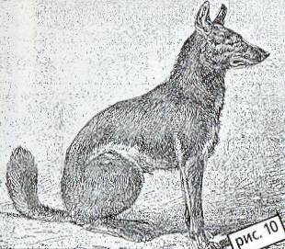
The Indian dol was discovered by Colonelcies. He wrote that this beast does not look like a jackal, nor a fox, nor a wolf.. Its size, according to the description, is the same as that of the average height of a sighthound. The color of the milk is beautiful browned red, on the legs, ears, muzzle and at the end of the tail is darker, and the bottom is lighter.. The tail is hanging and quite thickly covered with wool. These individuals live in packs and hunt in packs, silently catching up with prey. Capable of a long jump and very persistent in their pursuit..
The French described these dogs as real sighthounds, they could see them in the Paris garden of acclimatization / apparently something-like a zoo/
According to the descriptions of the colors of the Indian dole, it can be determined that these descriptions are very similar to modern red with black overlay, red or sexual with mazuurin color.
Very interesting is the fact of the constant return of this original color in sighthounds, seemingly so geographically isolated, living for example in the Sahara or Russia, despite the impurities of other breeds, which consciously, and sometimes not, happened for a single century.. Dark tong, murugous color, red or floor.. But not only the Indian dole is characterized by such color and assumption about the Indian shares an ancestor of a sighthound - it is nothing more than one of the assumptions..
Digging through the centuries and looking for more detailed information is completely useless, because they are very scarce. Most likely, after all, the homeland of sighthounds should be considered North-East Africa with the Nile Valley, wrote L. P. Sabaneev, who did not agree in assumptions about the Indian share with N. Kishensky. L. P. Sabaneev wrote that it was from there that sighthound dogs first spread to Arabia. In Asia Minor, Persia and the Carpathian steppes, sighthounds were brought by the Arabs, who conquered Persia in the VII century, Georgia and Turkmenistan in the VIII century.
Here, sighthounds mixed with indigenous, native, mountain dogs, often covered with thick hair. After that, a peculiar, new breed of sighthounds, oriental sighthounds appeared, among which, of course, various types were seen. Summing up all the historical facts, we can say only one thing that the eastern sighthound dogs inhabited the areas inhabited by Arabs, Turks and Tatars.
The territory that we used to call Russia, which previously included the Union republics (the Soviet Union), was once inhabited by Sarmatians and Scythians.
Herodotus is a Greek historian, describing the life of the Scythians, in the 1V century BC. wrote that this population, hunting, climbed trees, with the help of a bow they shot at game. Their dogs then caught up and caught the wounded beast. It can be assumed that these were already, in some ways, sighthound-like dogs. Well, at least the dogs that caught up and caught. Properties that are inherent in sighthounds.
In search of archival materials, I went to many libraries and, one day, in the State Central Library I found a brochure "The Legend of the Great Princes of Kiev". It says that Prince Yaroslav (11th century) was the first to establish written laws concerning catches and catches. The prince's laws were printed in Russkaya Pravda. About dogs it said "... if anyone steals... dog /catching dog/, then 3 hryvnias to the treasury"... will pay, "... and to the owner - hryvnia." Of course, this was not the Russian sighthound we are all used to seeing. It was a sighthound-like dog that was used in the extraction of the beast.
It is necessary to clearly imagine that there, in the area where man intervenes, whether it is the breeding of livestock, horses ... or /in our case/ sighthounds, there is a constant improvement of breeds, their, albeit small, but a change ... The Russian sighthound-like dog was also improved. Based on, albeit sketchy, archival, but information, you can gain courage and declare that the sighthound-like dog in Russia existed for a long time. And here I will try to try to prove it to you: In 1099 in the "complaints of kn. Sviatoslav of Chernigov on the devastation of his land by the Cumans" first appeared the word "psari", that is, people who were in the service of the princes. They were charged with caring for dogs to keep them and go hunting.
In the "History of the Russian State" N. M. Karamzin had a mistake in that he attributed the use of "dogs" in hunting to the reign of Vasil Sh /early 16th century/, but if under Karamzin the frescoes of the Kiev-Sophia Cathedral representing "animal catches" had been discovered, then he certainly changed his mind. Here are some of the frescoes from the time of Grand Duke Yaroslav and earlier.
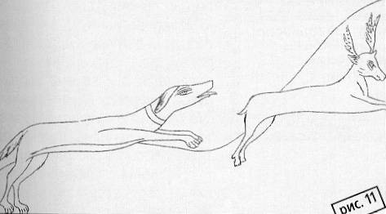
The first descriptions of the Russian sighthound can be seen in the archives of the1st century, where there is a record of the marriage of King Henry 1 of France with the daughter of Grand Duke of Kiev Jaroslav the Wise Anna.. She brought with her to France 3 dogs, two males / black and gray/ and a golden bitch, apparently sexual.. These dogs were very close to sighthounds.
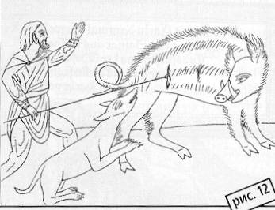
And then sketchy information about them. In the fifteenth century, in the spiritual testament of Prince Vladimir Andreevich of 1410 . we find the words "psar", "dog hunting" - he writes: "son kn. I bless Ivan Vladimirovich by seniority on the way... to the stable way, psari...".
The charter of 1453 says: "Chase away beavers... and keep dogs."
Almost 100 years later, in 1504, in the charter of the Grand Duke of Moscow Ivan III - a testament to his son Semyon Ivanovich - "in Moscow the village of Lutsinskoye and with a mill, and with a parley. "
Boyars, bureaucratic people also kept psarny yards, psarei, servants for hunting. Ivan Yurievich Patrikeyev, who served under the Grand Duke, mentions psary, falconer, etc. in his will. A.
In the prayer book of Grand Duke Vasily III, Father John the Terrible, on one of the pages we see the Prince participating in a prayer service, a sighthound-like dog lying near his feet.
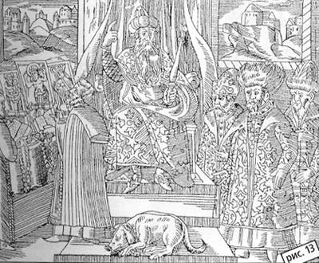
A rather extensive description of the grandeur of hunting in his "Noteson Moscow Affairs" gives Baron Sigzmund Gerberstein /1486-1566/. Baron lived in Moscow in 1517-1526, his notes were a bestseller of his time and were translated into many languages..

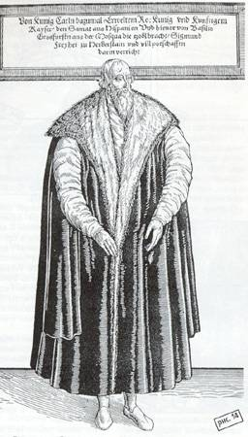
Baron HerbersteinIn
this book, he writes about the Russians' fascination with complete hunting, t. a. hunting sighthounds along with hounds. Riders with packs of sighthounds (nowadays a pack is 3 dogs, one of which is necessarily of the other sex, at the same time a pack meant 3, 4, 5 and 6 dogs), standing on the edge of the forest. Medelyan and sniffer dogs, apparently, hounds drove the beast at them. They chased with their voices. The one on whom the beast flew out, lowered his sighthounds from the packs and, as a rule, the beast was caught. A. Herberstein writes in his notes that the baiting was carried out by dogs with fluffy tails and ears, incapable of a long race. Most likely, obviously, they were eastern fold-eared sighthounds. A. Herberstein describes the presence of the Tatar prince Shikh-Aley and the Tatars at the hunt and indicates that they were, as it were, the leaders of this hunt, which the Russians did not yet know so well.
In the "History of the Russian State" there is an entry that in 1519, Christian P, King of Denmark, sent the French King Francis 1 sighthound of the Russian breed. In 1517, Vasily III concluded a trade treaty with the Danish king, in which, apparently as a gift, he sent him sighthounds of the Russian breed, as a sign of friendship. This suggests that dogs in those days were valued and were a sign of special disposition.
Beginning with the reign of Basil III, hunting with dogs in all its splendor, with which it was furnished, became almost a political event, i.e. K. ambassadors of other states were invited to it - Polish, Lithuanian, Tatar khans, various eastern princes, rulers and sovereigns.
Dog hunting was very widespread during the reign of Ioan theTerrible. The hunting palace of Ioan the Terrible,which reflected the hunting spirit of that time, has survived to this day.. Later, after the death of the king, he changed hands..
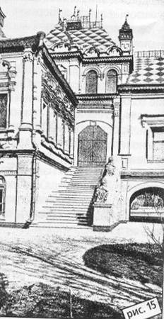
According to legend, the builders of this Palace were the famous stories of Bram and Postnik, who built the Cathedral of Pokrovskoy or as it is also called the Temple of St. Basil, standing on Red Square in Moscow..
In the interior of the Palace draw attention to the arches painted by the artist Morozov - 4 frescoes.. On one of them you can see John the Terrible on his favorite white horse with a falcon on his hand, accompanied by sighthound dogs.. Figure 17 After the death of John the Terrible Palace this one has not been used for almost 100 years.. It was only under Tsar Alexei Mikhailovich, who passionately loved falconry,that the palace was repaired.. The king visited him only a fewtimes, then the palace was abandoned..
Tsar Peter I presented the palace to A. D. Menshikov. After menshikov's exile, the property was confiscated, and peter 2 presented the palace to G. D. Yusupov, about which there was a record on the walls of the palace. The palace has survived to this day and still stands in B. Kharitonyevsky Lane in Moscow, near Chistye Prudy.
Ioan the Terrible moved a significant number of Tatar princes. from Kazan to Yaroslavl and Kostroma Hubernia. Forced them to convert to Christianity and endowed them with estates. Since then, the confluence of Tatar and Russian has given a strong spread of sighthounds throughout the Russian state.. It was from this moment,fromthe second half of the 6th century began the formation of the Russian breed of sighthounds.. Tatar sighthound was difficult to get used to in the climate zone of the Russianstate.
That's where the path begins to that perfect, exceptional beauty and hunting qualities of a sighthound dog, which we have today..
Quite often the question is asked about how many years, after all, the Russian sighthound ... This breed was established in the form in which it is today a little more than 100 years ago. But, if we talk about the Russian sighthound-like dog, which was proudly, as a sign of friendly disposition, sent as a gift to the rulers of foreign countries, then we can say that it is almost 9 centuries old, t. K. the first records of it date back to the 11th century !!!
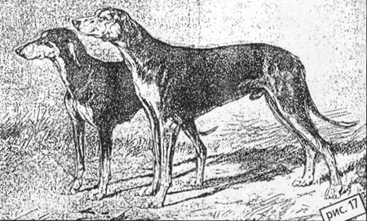
Eastern Sighthound
Tatar sighthounds /oriental/ belonged, mainly, to the highestclass. Accordingto therecords, the dogs that have survived to this day were loved and very pedantic about theirbreeding. They were bred clean and kept from degeneration only fresh blood of southern sighthounds, which from time to time brought.. Christians did not follow the thoroughbreds of dogs and treated them in a completely different way to theirbreeding. Eastern dogs werefew, and the cold climate in Russia gave itself to know, so during this period there is a conscious interbreeding of Tatar /oriental/ sighthounds with local hunting dogs, witty, wolf type..
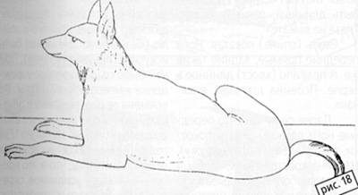
Siberian fishing dog
By the end of the6th century in the Yaroslavl and Kostroma provinces, nobles had a new breed of sighthounds with long hair all over the body, combs /dog's dressing/, mane around the neck and large standing or full-standing ears.. In Russia at that time there were so-called catching dogsthat drove the beast on rough terrain.. Such dogs were found in the regions of Northern Russia andSiberia. Russian hunter P.. E.. Yasherov from Siberia pointed out that in the mouths of the river Lena there were very stalwart northern dogs, in the warehouse surprisingly reminiscent of sighthounds.. Heads arenarrow, their ears are crossed and pressed like modern sighthounds.. These dogs were designed to catchdeer inwinter. Dogs met up to 17 tops /75 cm/ height.
N. P. Kishensky in his work "Experience of genealogy of dogs" 1884 He raised the question of the origin of various breeds. He was the first to point out that the Russian Sighthound is the result of crossing a northern wolf-like dog with an eastern sighthound. "The sighthound canine," writes N. P. Kishensky, "has " the same wolf manner of waiting for prey at close range, aiming lying down and catching with one short desperate effort, the latter, which served for many generations as the subject of selection, developed into a fabulous throw, like a rifle shot." One of the travelers N. L. Gondatti gave a complete description of the north-western dogs in 1885 /Large commercial dog of Siberia/.
I bring it in someabbreviation:
" The dog is very large, covered with a thick dog of different colors. Gray-brown predominates. The muzzle is always dark. A dog on the neck forms a clutch. The dog is thick, forms a latrine, lighter than other colors on the neck, sides and thighs. The rule (tail) is always kept hanging. The head is wedge-shaped with smooth hair. The eyes are big on the rollout. The ears are small, semi-erect. The body is short, massive, resembles a wolf, has an explosion. These dogs are quite frisky and have a throw. Their instinct is poorly developed, they work only by eye, do not bark and, enough, are angry with the beast. When caught, keep him tight."
Itis known from the archives that almost 50 years after the relocation of the Tatars to Yaroslavl and Kostroma, Tsar Boris sends as a gift to the Persian Shah 2x, already Russian type of sighthounds.. During his reign, many Polish harts /type of Polish sighthound /were brought fromPoland. The slyation of this blood somewhat ennobled the appearance of the Russian. Improved the rule, ears, general look.. It gave some elegance.
In the troubled times of the late yearX-6 and the beginning of the7th century dog hunting flourished, but in the center of the state, apparently, there were no good sighthounds and Tsar Mikhail Fedorovich had to send in 1691, in the Kostroma province, people for sighthounds.. и начала Х This suggests that the Kostroma province was one of the places of great distribution of the sighthound.
С пришествием на престол династии Романовых начинается расцвет породы русская псовая борзая.
In 1635, the first edition dedicated to this breed and hunting with it appeared. "Regulus belonging before the dog hunt", written by the stolnik, a Riga German in German Christian von Lessing. The book is written very briefly. When describing the articles of the dog it is said: "I must show you a statuesque dog, choose it as follows: the head is dry and elongated without a fracture, the forceps / part of the head from the eyes to the nose / should be long, equal to the head. Eyes on the rollout." Steppe / back / rolling. The front legs are straight, the hind legs are the same. And the rule /tail/ is long in the crescent. The dog is long, hanging." He goes on to write that the front legs should have elbows turned in the field (outward). The width of the sacrum is such that 4 fingers fit freely. Edges are low, drooping, dense. Also, H. von Lessing in his work wrote that the Russian sighthound at that time in Russia had a lot of types, because depending on the region where it fell, it was poured with a Polish hart, and a dog resembling a modern Laika, and maybe other breeds. But the main type of breed was retained, despite the impurities.
Inconclusion, Christian von Lessing noted that the breed created in Russia and in Western Europe was in great fame because of-its friskyness and work on the wolf.
Peter I was not a great lover of hunting, he was mostly occupied with the development of the state. But his daughter Elizabeth and grandson Peter II were passionate dog hunters. Elizabeth Petrovna, the daughter of Peter the Great, according to too meager records, but, nevertheless, which have come down to us, could not sleep at night, indulging in dog hunting, so much she loved her. At the same time, she took a direct part in the baiting of the beast, on a horse and in a man's costume.
Under Peter II, the position of jägermeister was first established. Peter P hunted with great pomp near St. Petersburg and Moscow. So in the autumn of 1729, a pompous, magnificent hunt took place near Tula, where, according to archival records, 4,000 mermaids and 500 foxes were hunted. Soon, however, after the Tula amusement, Peter II cooled down to hunting and gave away all his dogs.
Anna Ioanovna, was a great fan of hunting and shot perfectly, in archival records I found a record that she dissected the bullet into two halves, getting into the blade of a soldier's executioner, dug into the ground /certainly, this can be a skillful exaggeration/ It created a special institution of imperial hunting. During her reign in central Russia begins the import of sighthounds.. From the letters of 1734, года stored in the archives, we can conclude that at this time begins the increased interbreeding of the bruda, Polish, English sighthounds between themselves and the canines..
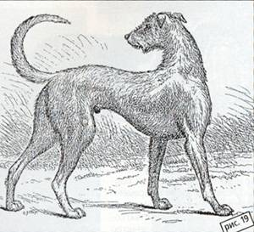
Sighthounds
So was, for example, the famous male Beast of Prince Baryatinsky G. F., who took a seasoned wolf alone. He was descended from Reed Cap, an Irish wolfhound discharged from England and a canine bitch.
The addition to dog blood of a brudast sighthound gave the concept of thick- The thick dog had a thick long dog, was a huge height of 19 verts /85 cm/ with well-developed muscles /black meats/. It was massive, the head wider, the eye is always black and small ears.
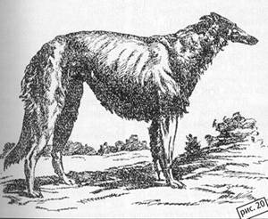
The
thick-puffy was distinguished by a shorter canopy, less dense, smaller stature, lighter bone, less developed musculature, the head was narrower, even somewhat sharp-pinched / meaning a forceps, t. a. part of the head from eye to nose/.
The ears were small in a good puff/t. a. well pressed to the neck/.
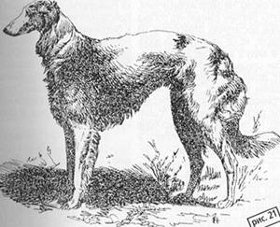
Dog
At this time again there is a conscious mixing of thick-hearted to pureps, Polish harts and English greyhounds.
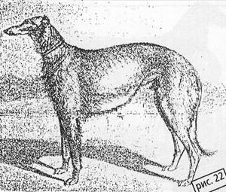
Pure-pop
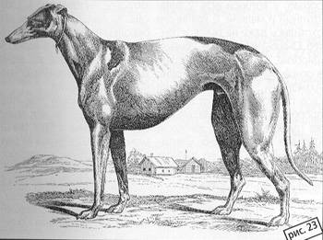
English.
Lovers and connoisseurs of dog hunting were Tsars Alexander II and Alexander III, Nicholas II, Grand Duke Nicholas Nikolaevich (uncle of Nicholas II), the owner of the Perchino hunt. And many, many more Grand Dukes from the Romanov dynasty.
But now, in 1807, another breed of oriental sighthounds was brought to Russia - gorki /mountain sighthounds/. They were brought by Count Gudovich I. Q. And again there is a conscious mixing of the blood of the now canines with the mountain sighthounds.
The most famous, at one time, sex-singing male Heart, belonging to Major General P. A. Ivashkinu, descended from dogs
And. Oh,Idon't know what Kologrivova was a mixture of a mountain with a pure dog. It was different because not a single animal would leave it if he worked alone.. In the back of the pack, he always trudged frombehind. The exceptional frolic of this male pushed the Russian rich and passionate hunters to the fact that they began to import mountain dogs and deliberately mixed them with dogs.. At the same time, in the breeding of a certain type, some breeders adhered to the type of dog, and other mountain..
In one of the libraries I found detailed articles L. P.. Sabaneva, where he talks about mountain sighthounds..
He wrote that the types of oriental sighthounds are quite a lot,they differ in height, quality of the dog and have some differences in the exterior..
Mountain sighthounds, he wrote, are found in Asia Minor and Presia.. Russian hunters are called mountain sighthounds, living in Armenia and Kurdistan, which are also called "Kurdistan".". Presumably, in the Caucasian countries from the interbreeding of the Arab-Baghdad sighthound with a mountain shaggy dog there was a new breedof fold-hounds, which later divided into mountain and steppe Turkmen..
In general, года known "slideгорка" has become since 1801, after the accession of Georgia..
Some Russian hunters L. A. Stolypin, A. V. Zhikharev led the breed of "gorok" almost in purity, constantly writing out fresh blood from the Caucasus. There was a small variety of "slides" - these are the so-called Anatolian dogs, as it was believed - these were, in fact, the degenerates of the "slides". Count I. V. Gudovich brought to Russia 3 small dogs, which were very frisky. It was this quality that pushed Russian hunters to the fact that they began to look for small "slides" in the Caucasus. Kutsykh dogs were kept by O. N. Glebov, Khodalevsky from the Saratov province.
They were also at the Tchelishchevs in the Kaluga province. The most famous in Russia were the "slides" of A. V. Zhikharev, who led the breed since 1818, as he said himself. He kept them indoors, in warmth and very carefully cared for them, very carefully protecting them. Contemporaries wrote that "Mocker" by A. V. Zhikharev and "Fatma" by Count A. V. Gudovich are typical representatives of the breed. "Fatma" in 1894 at the exhibition received the Great Silver Medal and was noted as a very breed dog.
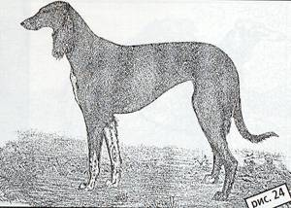
Fatma
L. P.. Sabaneev wrote that there are a lot of varieties of "rollercoasters" but all of them are not researched.. A lot of "rollercoasters" in Turkey, there they enjoyed great honor.. For them in winter sewed warm popons, and for summer light from flies and other nastiness, which irritated dogs.. Popons were always made with grace andluxury. Dogs have always had a special bed, fed them meat.. On the hunt they were guarded and,ifthe hunter believed that the dog had already done enough on the hunt, it was not released even in full view of the departing beast.. Dogs are specially prepared forhunting, making them special rubbing and massage, just brought in order after hunting, rubbing muscles.. As arule, only 1 "hill"was taken on the hunt. ". Dogs were very loved and zealous tothem, often branded..
There were also other varieties of "hills", according to Ahmed Bey, one of the honored hunters of Sultan Mahmud, the first chosen breed among them is the Aleppo sighthound, which has 2 types: large and small. Even lions and panthers were hunted with large ones. They were short, downtrodden, wide, ears in a curl. The color is mainly piebald. As Ahmed Bey said, this breed originated from the sighthound prophet Muhammad... The small ones are smooth, but the same as the large ones in description. They hunted gazelles, foxes and jackals with them. They were highly appreciated for their viciousness and agility. Murad Pasha, a former Hungarian general, offered Ali Pasha up to 500 Turkish pounds for his sighthound, but he refused to sell it. He presented it as a gift to Murad Pasha. The dog, in his opinion, was priceless. For this sighthound, Ali Pasha received a Hungarian carriage with the entire harness. There was in this breed a very famous male Kara-Kush, who in one day of hunting took alone 5 hares, 2 foxes, 1 jackal and detained a wolf. The offspring of Kara-Kush were distinguished by the same qualities.
According to Ahmed-Pasha, the second breed should be considered the Thessaly sighthound. It was also divided into a large variety and small. Large - smooth, with a good warehouse, beautiful eyes, smart and meek.. Their origins are very ancient. In the Kalabak Valley there were 2-3 villagesthat specifically bred these sighthounds for sale.. They sold them to high-ranking officials and even abroad. In the late 40s of the 19th century, allson's bank house in Constantinople was bought in Thessaly by 40 sighthounds of this variety.. They were bought at the expense of Count Stroganov. After the purchase the sighthounds were sent toOdessa.
According to eyewitnesses, these dogs possessed excellent hunting qualities, stopped wolves and even wild boars..
Small dogs of this variety were taken to Arabia by the surname Turhan-Bey,the first Muslim winners of Thessaly and Greece, as they were called.. Dogs these besides hares also took droff and geese. Only when hunting geese and droff, hunters used cunning to help dogs.. The day before the hunt, they scattered the grains of maize or peas soaked invodka. During the nightthe bird ate thisgrain, got drunk and in the morning it was possible to take "warm".".
Varieties of this "mountain" breed, one way or another, were mixed dogs, thus they were divided into intra-breed types, depending on the place of residence..
The mountain sighthound, according to the descriptions of the same L. P. Sabaneev, is the most perfect sighthound and adapted to jumps not only in the steppes, but also on mountainous and stony soil. It was a more advanced type of oriental sighthound. In their pure form, these dogs were very rare. The head of the slide was small, narrow. The ears are necessarily long, hanging under the burka, i.e. covered with a long soft dog. The neck is long. The back is straight or with a small spring (top) - arched back, smooth line. The dog is short, smooth, soft. The eyes are barely noticeable. The most typical color is black and black tan. They were 16 verts tall /71 cm./, somewhat lower.
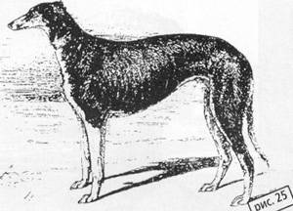
Crimean sighthound
The Turkish campaign of 1828 gave an opportunity to bring to Russia another breed of eastern sighthounds - the Crimean sighthound.. The Crimean Sighthound is a somewhat generalized concept about steppe sighthounds, common throughout Southern Russia, in the north of the Balkan Peninsula, among the Tatar peoples.. In more distant times, this dog was called a Tatar sighthound and it was spread further north.
The close acquaintance of Russian hunters with the Crimean began around 1795. года. Oh,Idon't know what Poltoratsky wrote that in 1860-62, годахat the timeof the mass migration of Tatars to Turkey, the best dogs were taken away.. But many dogs in the territory of Eupatoria remained abandoned to their fate. Many ofthem, according to eyewitnesses, died of starvation.. Gypsies could buy them fornothing. Clean Crimeans almost did not remain, only a few remained in the remote auls and were valued veryexpensively, but they soon remained.. According to Yu. Tarasova, the most beautiful Crimeans in 1830-1840 were at the famous horse breeder I.. P.. Petrovsky in the Leaven county of Orlovskregion.
According to the records of L. P. Sabaneev, the Tatars inhabiting different provinces of Bulgaria kept several varieties of eastern sighthounds, close in type to the Crimeans. Nogai sighthounds, as they were called. We hunted deer and goats with them. The hunts were rounded up, sometimes gathering up to 200 horsemen, who fanned out, sometimes for several miles, moving through the fields. The second breed was considered a variety of "Krymok", which in most cases were accustomed to working with a falcon. The third variety of very small crimeans, which, usually, the rider planted in front of him on the horse. Such a sighthound was allowed from the horse only when the hare was already caught up.
There were also some features in the organization of the life of dogs at theTatars. Very interesting bed for sighthounds. It was made on the top of theroof, almost next to the stork's nest.. The dog climbed up to the roof on a specially made staircase for her. Above the bed was made even, so-called, a special umbrella of reeds, which covered the dog from the sun's rays.. On the roof less bothered flies and other insects, and accordingly the dog was less worried.. Dogs were guarded and groomed.
On the exterior of the Crimeans were more roughthan slides.. Smaller in stature, ears shorter and usually no burqas.. Were very strong, but did not possess a throw like a dog or a roller coaster.. Her head was small and squat. The eye is light.. The neck is medium long. The back is straight with a wiretae/trough on the back immediately after the withers/. The dog is short and rough. The combs are rare notlong. The colors are often black and black, but also black-faced with a nettle.. Murugi/red with black spray /./. Murugo pegi. Red with mazuurin / blackness on the muzzle/.
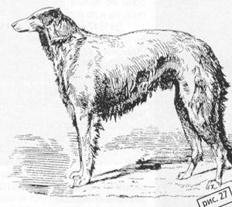
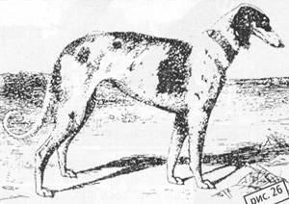
Modern canines
by the 60s of the 19th century very many canines carried the blood of Crimean sighthounds.. There was a mixture of different types of dogs and, if previously it was possible to distinguish a truly dense and pure-, now dogs were only worse and better dressed /covered withwool/. Earsbecame, as a rule, loose and in puff met very rarely..
So,the whole history of the birth of a Russian dog sighthound, according to Sabaneeva L.. P. - the famous author of the treatise "TheSighthounds and the Hounds" can be divided into 4 periods:
The first - from the 3rd century to Tsar Alexei Mikhailovich, during which the breed of Russian dog sighthounds was produced and began its development of dog hunting..
The second is from von Lessing's Regula, with the fascination with brudasty sighthounds and the breeding of a new breed of Courland dog and thick-leaved.
The third is the period of liberation of peasants from serfdom, fashion for eastern sighthounds, mixing of all types of sighthounds, disappearance of dense and dog..
The fourth period is the mixing of all subtypes of the sighthound and the receipt of a single breed - the breed of the Russian dog sighthound..
From this moment begins the triumphal procession created by the Russians unique breed not only on the land of TheRussian, but also around the world..
Until 1842, we did not have magazines and serious publications dedicated to dog hunting and sighthound racing in particular inRussia. Except for small brochures issued by some small publishers..
In 1842, the magazine "Horsebreeding and hunting" was founded. ". In this magazine published articles of all leading dog hunters and breederswho possessed a real Russian hunting language.
Sighthound owners were free to publicly exchange views on different topics, express their opinions, share experiences..
In 1862, the "Moscow Hunting Society" was opened in Moscow, under the chairmanship of Talyzin.
In 1873, on the initiative of Count Vasily Sheremetyev, the ImperialSociety for the Breeding of Hunting and Fishing Animals and Proper Hunting was organized inMoscow. In this regard, meetings of dog owners, exhibitions, display of dogs' works on friskyness and malice /chelli/. выставки Around this society formed a circle of dog hunters and breeders, who aimed to support and revive the fading, at that time, breed of Russian dog sighthounds.. The magazine"Nature and Hunting" published at that time provided great help in the revival of this breed. On his pages he printed the results of the garden and exhibitions. Controversy breeders, fascinating stories of sighthounds, written in real Russian..
There were magazines such as "TheHunter'sFamily,""The Hunting Gazette,""The Hunt." ", "Охота But, unfortunately, not many of them have survived a long edition.. Some of them lasted no more than 4 years..
A very large role in the restoration and maintenance at the proper level of the breed was played by a world-famous lover and breeder of sighthounds - His Imperial Highness Grand Duke Nikolai Nikolaevich. Since childhood, he was a passionate hunter and participated in the hunts of his father in the Peterhof estate. But near St. Petersburg hunting with a Russian sighthound was not interesting because of-the marshy and rocky soil and the Grand Prince puts his hunt in the estate ofBaron Delvig in the Tambov province..
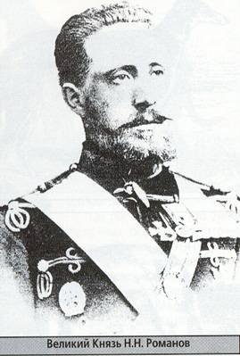
Everyyear, September and October, the Grand Prince spent on this estate and hunted with his sighthounds.. Since 1886, the Grand Prince begins to engage in breed and in 1887 he acquires the estate of Perchinoo in the Tulaprovince, where he puts the beginning of dog hunting, the only one in Russia in its composition, the blood of dog sighthounds, in the typical and correct conduct of complete hunting, known not only in Russia, but also far beyond its borders..
Andnow, nowadays, if there is an opportunity to trace the pedigree of sighthounds to 20-30 knees, many proudly saythat my dog has in such-that kneedogs Perchino hunting..
Fortunately, the book "The Dog Hunt"of his Imperial"
Highness Grand Duke Nikolai Nikolaevich in c.. Perchinoo Tula Gubernia 1887-1912, гг written by Dmitry Valtsov, who for 20 years participated in this hunt..
The soul freezes when you open this book and read the lines:"From the deignment of his Imperial Highness Grand Duke Nikolai Nikolaevich, this work is dedicated to all Russian doghunters." :"
Dmitry Valtsov begins his book with the words that are relevant today:"Dog hunting is a dashing fun of our ancestors - and now the hearts of Russian hunters, cherishing the covenant so fantiquity, supporting the breed of blood sighthounds and hounds dogs and all the traditions of this noble fun, both in the rules of riding with complete hunting, and in strict use of hunting.".
Perchino hunting - it was a whole complex aimed at the correct content of the Russian dog sighthound.. It included complexes of blood breeding and poultry farming. In Perchino there were herds of cows of shvitz breed, taken from Switzerland.. Otra sheep of The English Oxfordshiresaun breed and Russian oxon. Herds of horses of Arden and Cabardine breeds were kept.. There were factories of English pigs breed "tamier". Near Perchinoo on farms bred and thoroughbred bird: Ruan ducks, French chickens "Ku cude malin", "Faverol". There were dovecotes with thoroughbred pigeons "Thurman".
All this blood breeding was conducted under the direct supervision of Grand Prince NikolaiNikolaevich. Foreign breeds bred in Perchino were constantly replenished by extracts from their homeland of new blood producers.. All this was contained in a remarkableorder, as well as dog hunting, for which this livestock farm was created, which produced milk, eggs, meat..
What was the device of the psular court of Perchinohunting? A very large place was set aside for the release of sighthounds, about 5 tithes with a river and a pond.. In the middle were 9 stone houses for the Russian dog sighthound.. With room for 12 dogs in each, with rooms and kitchen for people caring for dogs.. All issues, all houses were specially divided into rooms for bitches, bitches with puppies, puppies, males and old dogs living their age.. Exactly the same premises were made for English sighthounds. For hounds, the dogyards were of a slightly different type.. All the rooms were heated and without drafts. The layout of this structure was thought out, the Grand Prince himself was drawn an internal plan, which was built all the houses for keeping dogs..
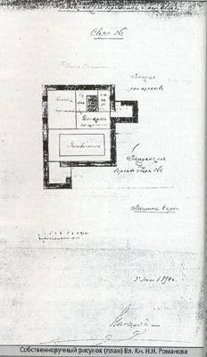
A hospital for dogs with two isolated rooms was built 5 kilometers from Perchinoo, on the other side of the Upa River and on the banks of another river with key water. The sick dogs were taken to this hospital at the same time, and the suspicious dogs were isolated in the second room.. Thus, the sick dogs had no contact with the main territory..
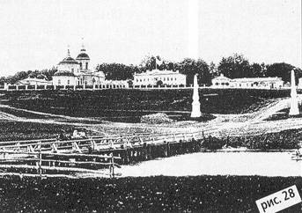
So, to the smallest detail was thought out everything for the maintenance of Russian dog sighthounds, English sighthounds and hounds, the entire composition of Perchino hunting.. How much work was put on the creation of this hunt and on getting blood, shiny, exterior and working dogs, which amazed with their data not only connoisseurs of Russia, but also experienced in the beauty of foreigners.. I want to quote Dmitry Valtsov, who very accurately articulated the issue of getting a blood dog, a highly breed animal, surprising everyone with the correctness of addition and working qualities: "We, very often, do not pay proper attention to the environment and conditions in which the animal should be brought up and developed.and all our hope is placed on blood and blood, forgetting that blood is the product of the upbringing and maintenance of a number of generations of animals and that without leaving the known blood, it is possible to completely lose all the virtues of the breed, if you put a number of generations in inappropriate if you put a number of generations in inappropriate conditions."
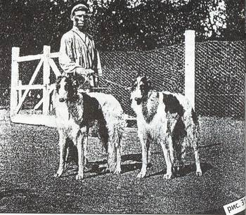
In addition to houses for dogs and other animals in Preshino there were special buildings for the manager of this farm and for his assistants. The two-story palace, where all the receptions took place, stood against the background of the park with its centuries-old lime alleys..
Already entering the front of the palace, you could see the dwelling of the hunter.. The walls were hung with hunting paintings, portraits of English and Crimean sighthounds from the hunt of Augustus the Great Prince.. The playgrounds were filled with stuffed wolves, poisoned by the pack of sighthounds, with the participation of the Grand Prince.. There was a special room in this palace for a solitary brood of all the sighthounds of Perchino hunting. The walls of this room were hung with portraits of the best manufacturers.

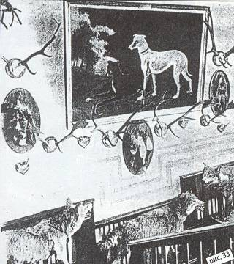
They were painted by the artist amateur and dog hunter Georgi Konstantinovich von Meyer. The broods were very interesting, t.. To. often in the dogs, displayed for inspection, you could see a copy of the famous ancestors, portraits of which hung on the walls of this room.. At the same time, sometimes not only the shapes, type and color were the same, but even the location of stains on the wool..
In front of the palace were broken circular flower beds with a circular road, on which the sighthounds were conducted in a half, in pairs, one by one, when broods of the entire Perchino hunt were conducted..
Spectators admired the brood from the special terrace..
The view from the balconies and windows of the palace was open to the valley of the River Upa with its baymeadows, lakes, groves, villages and villages - a wide view of kilometers for 15, closed on the horizon by a solid edge of the forest.. A true view of native Russian nature. The property in Perchinoo was constantly expanding with the purchase of new and newland.
In general, it was a huge scientific-cultural complex.. Now for our contemporaries it is all lost and you can only shudder at the mention of this hunt or stand in the shadow of huge poplars, still remaining from those times, and look at some-- that miraculously survived the church.. Destroyed everything! Far from bombing during the war.. But with the destruction of these traditions, these cultural values, we destroy a part of ourselves, part of our soul..
It is not the first time and not the first year on the Perchinoland, the land known to all sighthounds in the world, this sacred Mecca embarked owners of sighthound kennels living abroad.. And it is necessary to see the faces of these people, seemingly so far from Russian culture.. They were stroking the ground on which sighthounds once-ran.. Some of them could not step over some- invisible barrier, a boundary to go further, and when stepped over, their faces changed, as if in their souls burst into the spirit of the time and it seemed that around us there is no more devastation that remained from the palace and the entire Perchino complex.. Many weptwhen they hit this land.. Each of them took with them a handful of Perchino land, and I am sure that they are sure that they are sure to every lover of the Russian dog sighthound abroad, this unique beauty and grace of the breed, will tell with a sinking heart about how they visited Perchinoo..
It's a shame for us,the Russians.. But we could save, and if not save, then revive our ancient cultural traditions.. And the whole world could then say - there was no Perchinoo, and there is and will be.. After all, Perchinoo is not only a Russian monument of the old culture, but also a cultural monument, before which fans of sighthounds all over the world worship..
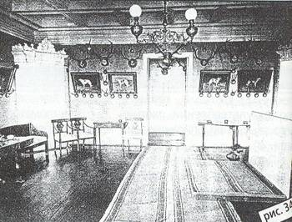
To finish the description of this most revered, the largest in its accumulation of breedingmaterial, on the blood and working qualities of dogs of Perchino hunting, I want the words of the author of the book - Dmitry Valtsov:"Inconclusion I must say, if such hunting as Perchinoo was abroad, for example in England, it would be known throughout the country and would be its national pride.. But in Russia, only a small circle of faces knows about such a large nationalhunt. Many dog hunters have never seen it, have not even been interested in getting acquainted with it, although Augusta owner has long given his permission to show dogs and all its device to all interested in this case... Foreigners came from Holland, Belgium, France, America and got acquainted with this hunt;; Americans have even purchased dogs... The Germans, Belgians, French, Americans despite the distance range, unfamiliarity with the Russian language and other difficulties - all this to overcome and familiarize themselves with this hunt, the merits of which they read in their sports magazines... If you think about how much work and money is used to achieve the results described by me, it is involuntarily sad that all this, so little is used by Russianhunters." так мало пользуются русские охотники
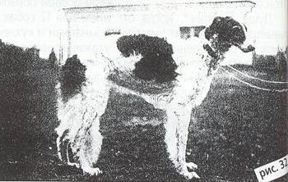
Nowadays it becomes sad that there is nothing left of the palace, from the fountain, the decoration of which so pleased the eye in the old days, there was only the remains of the fountain, which is littered with nearby houses.. But all this magnificence, which is invested in the work of many people, the souls of people who created a unique in importance complex, destroyed not by wars and naturaldisasters, but bythe hands of all the same people who dismantled thepalace and all the buildings sothat the stone on the stone is not left.. Miraculously survived three houses, which used to house kennels.. They look more solid than anything that was built in the post-war period.. Now people live in them..
In Russia, there were manyhunts, as a rule, they were called the names of their owners.. They differed by the type and color of sighthounds. Infact, you can very much list the famous and large nurseries /hunt/ many names of their owners.. All of them had-some kind ofparticular type, t.. To. work in them was carried out on inbreeding.. But the famous sighthound breeder N.. N. Chelishchev singled out 7 main:
Rice
PERCHINOSKY - combined all the best blood of ancient sighthounds and divided into 2 groups of dark and light colors.. Height 76-78 cm.. At first, these dogs were in the type of thick-skinned, but in the pursuit of friskyness, the backbone of dogsof both light and dark types noticeably eased..
Rice.
LAKE - A characteristic feature of these dogs was the humpback head and the sunset of the forehead back.. Height 76-78 m. The color is predominantly white with sexual or grayspots. The dogs were very bony and wide-backed..
Rice.
BIBIKOVSKY - Males 74, 72 and smaller. Color of all stripes except black. The dog was different, mostly stiff, not thick. The head is different in type, mostly rough. Quite bony, but in appearance the dogs were not interesting. According to the field hunting qualities, these dogs were highly valued. Rice.
BOLDYREVSKIE - Males 74-76 cm tall, 68-74 cm tall. The color is white with sex or white with red. These dogs were lighter than the Lakes dogs. They were very frisky, but they were not particularly angry with the beast. Rice.
TCHELISHCHEVSKIE - The tallest. Males up to 83, females up to 78 cm. The color is sexy in silver, red-sex, white with sexy in silver with red pegins, sometimes with chubar and gray. The head is long with a full and broad forceps. A distinctive feature of this type was a small, well-tightened ear, planted well above the eye line. Dogs are bony, but very frisky, with a huge throw, vicious and persistent. Rice.
SUMAROKOVSKY - males up to 78, up to 76 cm. The color is white with sexual or red spots. The head is straight, long with a hump and a wide forceps. A distinctive feature of this type was a lightened eye, submerged and poor pigmentation. This type was distinguished by agility and malice towards the beast. Quite bony, but the front part is more developed than the back. Rice.
GEYERERS - males up to 74, bitches up to 72 cm.. The color is black, dark red, sometimes with gray hair.. - The dark-reds had masurin /black mask on the muzzle/. The dog is not thick and stiff to the touch. The head is straight, but not long, with a notch on the tong, sharp-faced /narrow muzzle/. The yellow eye was a distinctive feature. The backbone was lightened, but the frisky of these dogs did not differ, and were angry to the madness.. No one could compare with these dogs..
You can dispute the descriptions of these types and their belonging to these plants, but even today there are different types of Russian dog sighthound.. The only difference isthat these types these days are not combined into one-particular hunting or nursery, as it was before..
Today we are not able to maintain kennels in 100-200 dogs or more.. And even today, for sure, it would be possible to reveal the distinctive featuresofany plant..
It seems to-me-that, что as in the old day, someone pays tribute to one type, someone else and can discuss this topic for a long time and to no avail, t.. To. it's a matter of all the same taste, certainly not going beyond the standard.. But to dispute what was written or described earlier, I think, all-afterall, is not worth it.. все They, the witnesses of that time, were more visible.. This does not mean that you should blindly trust everything that has been written about sighthounds.. It is necessary to combine all this scant information inherited by us and not argue about what happened and what did not happen. It is more worthy to pay tribute to all those amateurs and connoisseurs of the Russian dog sighthound, all those who have preserved this breed and reported in their notes to this day at least a small part of the history of sighthounds in Russia..
The historical stretch of the early 20th century before the war is covered so scarcely that it is necessary to collect information literally on the"scraps" hereand there.. Neither the Agriculturalnorthe largest State Central Library has brochures, virtually no magazines and articles about sighthounds covering this time.. But...
At the beginning of the 20th century, interest in sighthounds gradually faded.. The State Duma issued a new law on hunting. It affected the number of dog sighthounds.. A very small number of dogs began to appear at exhibitions. Factories began to sell.. Before the revolution, most of the hunts were sold out. The best livestock by the owners was taken out into exile..
Expert cynologist, Member of the Union of Journalists Estrin I.

