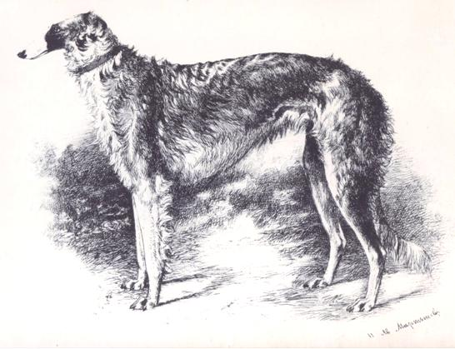

THE 1888 MODERN BORZOI DESCRIPTION BY NIKOLAI JERMOLOV

[EDIT](https://borzoipedia.com/wp-admin/post.php?post=268556&action=edit)

[Edit](https://borzoipedia.com/event/8081/?content-template-id=293026)

[Delete](https://borzoipedia.com/wp-admin/admin-ajax.php?action=cred-ajax-delete-post&cred_post_id=268556&cred_action=trash&redirect=277002&_wpnonce=7ae826cc94)

Cancel

Year of Event:

1888

**Country:**

[Russia](https://borzoipedia.com/country/russia/)

**Personal Collections:**

**Source:**

**Author:**

Dan Persson

**Dogs:**

**Persons:**

[Boris Cheremeteff](https://borzoipedia.com/person/8534/)  
[Nikolai Petrovich Ermolov](https://borzoipedia.com/person/3779/)  
[Matchevarianoff](https://borzoipedia.com/person/8303/)

**The 1888 Modern Borzoi Description** **by**[**Nikolai Jermolov**](https://borzoipedia.com/en/people/3779)

Introduction and Translation by © Kristina Terra

*The first detailed modern Borzoi standard was written by Nikolai Petrovich Jermolov, an undisputed authority on the breed in the nineteenth-century Russia.  The Jermolov family had bred Borzoi for over 200 years; and Nikolai Jermolov was considered one of the most talented and distinguished Borzoi breeders in the country.  The Modern Borzoi Description was published in 1888 and was approved by the membership of the Imperial Hunting Society. In his article, Mr. Jermolov alludes to the breed’s history and provides a general description of the ideal Borzoi.  This description was meant to set the course for the Russian Borzoi breeders of the late 19th century.  By that time, many different sighthound breeds had been crossbred with the Borzoi to enhance its field abilities.  Those breeds included the Courland Wirehaired Sighthounds (Kloks), Courland Longhaired Sighthounds, Mountain Sighthounds (Gorskayas), Crimean Sighthounds, Greyhounds, Chart Polskis, and Hortayas.  By the late 1880’s the breed was thought to have strayed too far from its original form and lost some of its most valuable qualities, such as the ability for brossok (a burst/dash of speed) as well as some of its fine aesthetic features.  Borzoi fanciers decided to essentially close the studbook and attempt to bring back their beloved and glorious breed by selecting for some of the Borzoi’s most essential features, at the same time keeping the improvements brought about by the crosses. Throughout history, all sighthounds were first and foremost functional hunting dogs and had been selected on their abilities in the field.  Therefore, there was not much need to discuss structural faults in much detail.  So instead, in his description Mr. Jermolov concentrated on the characteristics that distinguish a Borzoi from all other sighthounds.*



There are no longer any purebred Borzoi, as all modern Russian sighthounds had been crossbred with either shorthaired or Mountain sighthounds.  The crossbreeding with Chart Polski had most likely begun much earlier, but even the first Eastern Sighthound crosses started as early as a century ago in the Volga region.  Over the course of the fourteen Imperial Hunting Society exhibitions, not a single purebred Borzoi was seen.  So, since it is clear that we do not have the breed in its original and pure form, now we should only be preserving and improving the breed through correct selection.  We should also treat all Borzoi types equally.  Wide dogs with tight ligaments even if they are of average height (28” for males, 26” for bitches) should be as desirable as tall dogs with flat lean muscles and flatter ribs, as long as there are no narrow backs or narrow hips.  Such faults as a tail that is not perfectly shaped in a correct sickle, which sometimes also happens because the feathering on the tail is too heavy, ears that are set a bit wide or low, or coat that is not profuse but of the correct texture should not be considered major, and it is not wise to linger on such things.

Before I begin my detailed description of the Modern Borzoi, I think it is necessary to say a few words about the extremes in the opinions of Borzoi hunters.  I have been breeding Borzoi for 35 years, and my experience allows me to put forth my own opinion.  Huge massive dogs with enormous thigh muscles, super wide chests and barrel-shaped short ribs are not typical Borzois.  However, the other extreme, namely, the lack of muscles, a protruding backbone, flat-sidedness, narrow calf-like hips, and a narrow chest that seems to have been sewn up in the front are equally undesirable.  Extremely massive dogs evidence a throw-back to Mountain, Crimean, or short-haired Sighthounds.   As far as the dogs, whose parts are weak and do not seem to fit together, they are mostly the result of random breeding practices with no system or plan in place; not even Darwin’s Survival of the Fittest theory guides those practices; rather, all is guided by old breeders’ or kennel help’s crazy decisions.

A bloodline is of first and foremost importance in dog breeding.  Only by working with a bloodline, can we breed dogs of a set and sustainable type.  However, at the same time, we should be selecting for the correct features.  Otherwise, we could also make some faults dominant.  Moreover, we should not concentrate on field abilities alone and lose elegance.  By abandoning the bloodline or concentrating on speed or fierceness, we run the risk of loosing years of work.  The unforgettable P. M. Machevarianov and myself both have valued the excellent hare-hunting sighthounds that resulted from crossbreeding to the Mountain Sighthound.  However, this happened in another era, and now it is impossible to find such Mountain Sighthounds.  It is true that all immensely fast dogs had massively wide ribs, yet their bodies were as dense and flexible as solid rubber and their ligaments were tight.  Further, if one only selects for width and mass, the result may be fleshy and coarse dogs that become dominant in type.

I have never seen a fast dog among the ones with protruding backbones and narrow hips.  At the same time, I’ve known many fleshy Percheron-types that were not agile.  It is important to remember that while you can correct faults in a true bloodline, you will not be able to bring the pure bloodline back once you’ve lost it.  A purebred dog must be elegant and noble in looks.  Those are the sure signs of a true bloodline.  I even consider that sometimes a purebred look in dogs is much better than a simple plebian but balanced dog.  A true expert will be able to tell that a small flat-sided dog possessing running gear that is not outstanding but a correct head, good eyes and silky coat, will be much better for the breed than a coarse but well-put together dog with fleshy head, colorless eyes and coarse frizzy coat.

I would like to emphasize that now more than ever we must first and foremost focus on the breed type in our dogs.  As far as the dogs’ possible ideal construction and features, they should be approximately as follows:

1)      Size:  normal height at the withers for a bitch is 26”, or 30” for a dog.  One vershok (1.75”) either direction is just as well, as long as the overall balance remains.  So, a 24.5” bitch can be a true beauty and a good producer, just like a 31.5” male can be balanced and handsome.  However, heights less than 24.5” or more than 31.5” should be deemed as flaws rather than merits.

2)      Head (I consider that the head and muzzle should be described together).  The head should be lean with a back-skull that is not wide.  In profile, the dog appears almost Roman-headed, that is the back-skull and muzzle form a rather straight line, with just the slightest dip under the eyes and rise at the brows.  The muzzle should be narrow and long, but not excessively.  Too strong of a back-skull or too snipey of a muzzle are faults and usually occur when the bones of the muzzle and jaws taper in abruptly, rather than gradually.  The lower jaw should not be so much shorter than the upper jaw as to form an overshot mouth.  The nose should be black or dark, almost black.  The nose itself should not be pointy or have a dip in it.  Dish-faced profiles or muzzles that are too square are to be considered faults.

3)      Ears:  small and of thin leather.  We cannot require ears completely behind the occiput.  Though, ears that are too widely set or low are not desirable.  Ears should be close to each other and lay folded back.  It is good for a Borzoi to raise its ears up when in alert.

4)      Eyes are a bit bulging, large, resembling eyes of a snipe.  Dark brown or black in color with dark eye rims.

5)      Neck: should be slightly shorter and thicker on males and proportionally longer in bitches.  The neck is flattened laterally. A well-muscled and strong neck is required of wolf-hunting males, but to be able to catch a hare easily, a longer neck is better.

6)       Chest and forequarters.  The chest should not be narrow.  The shoulders should be well muscled, though the front of the dog should be a bit narrower and definitely not wider than the rear.  There should be a return of upper arm, so that when the dog is standing with its front legs parallel to each other and perpendicular to the ground, the legs are set under the dog.  Otherwise, the dog will seem to be on stilts.  The elbows should be turned slightly out (“into the field”).  The legs are strong, bony and wiry.  The hare-shaped feet should be tight.  The dog should be standing on its toes and nails and not on its heel pad.

7)      Back and topline:  The back should be wide.  The males should have more of an arch to their topline, whereas the bitches should have level toplines with the top of the rise somewhere over the position of the kidneys.  The hips should be wide.  A palm of one’s hand should fit between the hipbones.  It is good when there is no prominent sturgeon-like backbone, but, instead, when there is a groove that runs the entire length of the back.  However, we cannot be strict in requiring this of dogs, just like we cannot ask that all males have an arch to their backs and all females have level backs.  A bitch with a prominent topline, as long as it’s not too steep and as long as her back and hips are wide, can be very well put together.  Also, a dog that has a level topline, as long as he is not long proportionally but rather is compact and taught as a bow, can be a good producer.

8)      Ribs:  neither too flat nor barrel-shaped.  Somewhat convex so that there is space for lungs.  Ribs go down to the elbows.  The tuck-up is well defined; in a correct dog, no stomach should be visible.

9)      Hindquarters and muscles:  The hindquarters should neither be too straight, nor too angled.  The best is when they are just slightly long.  They should be parallel and wide when viewed from the rear, and in no case should the dog be close at the hocks, which always makes a Borzoi look ugly and cow-hocked.  The rear should be a bit wider than the front.  The thigh muscles should be average in size but very hard and strong.  The feet should be long and hare-shaped, and never be cat-footed, as in many short-haired sighthounds.  The hocks should be wide at the joint and taught.

10)  Tail:  The tail should not be fleshy, and not much wider than a finger.  The tail should be sickle-shaped and of medium length.  There should be profuse feathering on the tail.

11)  General appearance:  (When describing the head, I forgot to say that the occiput, or the rear part of the skull should be pointy).  The Borzoi should have a strong, hard, and well-muscled body.   The coat should be silky and wavy.  It’s better not to have too dense of a coat, but rather the correct coat in texture.  The colors are now very diverse, and one should not be judging the dogs strictly on the color.  The most typical colors are grey and gold.  The pure white specimens with no markings of any sort are seen rarely, but are very beautiful indeed.  Grey or gold markings on white, as well as sables/agoutis, both solid and spotted, are also typical.  Here is what I wrote to Mr. N. P. Kishensky for his book on “Genealogy of Dogs” and what Mr. L. P. Sabaneev published in his “Hunter’s Almanach” in 1885: “Just like the typical colors, all others can only be considered correct in purebred Borzoi if the color is not too uniform or bright all over the body.  A self-gold or straw- colored dog cannot be of the same color all over the body; but rather, the dog’s muzzle, feathering, throat, chest, underline, feet and backs of thighs should be of a much lighter hue gradually fading to white.  The same would apply to a self grey Borzoi.  Basically, purebred Borzoi should not be uniformly colored and not as rich in hue as shorthaired sighthounds.  Solid dark red or ash-grey colors, even with white feet, are not typical for Borzois.”  The noble appearance of a purebred Borzoi is mostly in its extremely lean and correct head, good eyes and elegant coat.  So all the features listed above together with this would produce an exemplary Borzoi, which would please the Purebred Dog Society.

I do not recognize the Chistopsovaya variety.  A breed should have an original type that is defined and set and I do not know such a variety of Chistopsovaya and do not know any breeders that have such a variety.  Chistopsovayas were the result of cross-breeding Borzoi with shorthaired, Crimean, and Mountain sighthounds.  The results of these crosses for one reason or another retained some of the mixed breed’s features.  Most kennels simply introduced Mountain or Crimean sighthounds’ blood and then bred on with the Borzoi, be it in the correct manner or not.  Hence, the Chistopsovaya type could not have been set, perhaps that happened only at Zhikharev’s kennel, or, possibly somewhere in Lithuania as well.  So, we see the Chistopsovaya only as evidence of a throw-back to the mixed heritage of a dog, but not as a separate breed or variety.  Often people mislabel regular Borzois without a lot of coat as “Chistopsovayas”.  However, it is not just about the coat, as a poorly coated dog sometimes can be closer to the Borzoi’s ideal, than a well-coated dog that has the shape of a Mountain or a Crimean Sighthound.  Even experts are not always able to make the distinction.  In Martynow’s album there is a portrait of Podar owned by V. A. Sheremetiew.  I do not know how accurate Mr. Martynow’s drawing is, but it depicts an enormous dog, which by no means is a Borzoi.  Here is one of the Chistopsovayas!

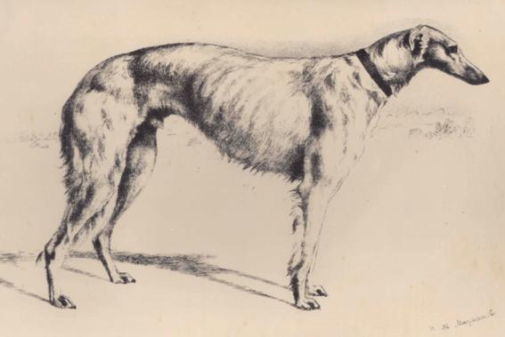

*Podar owned by V.A. Sheremetiew, by N.A. Martynow*