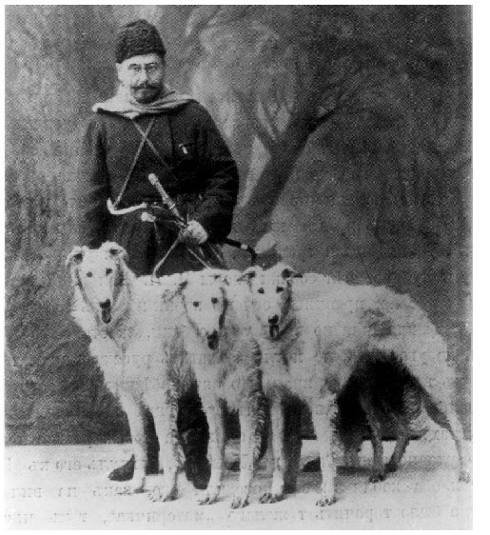

THE FIRST F.C.I. STANDARD
EDIT
Edit
Delete
Cancel
Year of Event:
1924
Country:
France
Personal Collections:

Spring:

Author:
Danielle Laurent-Faure
Dogs:

Persons:
Artem Konstantinovich Boldareff

- Preamble:
Until the second half of the 19th century, the notion of standard, as it is understood today, did not exist in Russia. "The standard was a tradition that was transmitted not by canine societies but from father to son by connoisseur breeders and all users" (Prince Serge Cantacuzène). The first document that resembles a standard (description of what the Barzoi must be) was written in 1888 by Nikolai Petrovich Ermolov, at the request of the Imperial Russian Society. It will remain in force in Russia for about thirty years. But other standards will also be published during the same period.
The end of the 19th century and especially the beginning of the 20th century saw the acceleration of Barzoi exports from Russia to different countries, especially Europe and the USA. At the same time, breed Clubs are created in each country concerned and each Club sets its standard for its own account. These different standards are more or less well detailed and reveal notable differences. Quickly, the need for supra-national harmonization appeared.
In 1911, the Fédération Cynologique Internationale (F.C.I.) was created with the aim of encouraging and protecting cynology and purebred dogs by all means deemed desirable. The founding countries are Germany ("Kartell für das Deutsche Hundewesen et die Delegierten-Commission"), Austria ("Osterreichischer Kynologenverband"), Belgium ("Société Royale Saint-Hubert"), France ("Société Centrale Canine de France") and the Netherlands ("Raad van Beheer op Kynologisch Gebied in Nederland"). But the First World War put an end to this federation.
In 1921, France and Belgium took the initiative to recreate the F.C.I.. By 1922 the FCI had 18 members.
In 1923, still on the initiative of the France and Belgium, the International Union of Greyhound Clubs (U.I.C.L.) was founded. Most of the countries of Western Europe will gradually become part of it.
- Event:
Before the exhibition in Ghent (Belgium) in November 1923, the U.I.C.L. wrote to Grand Duke Nicholas Nicolaevich, who had at that time gone into exile in France, asking him to designate the Russians who would be most capable of judging the Barzoi race at this exhibition. In response, the Grand Duke suggested a panel of three judges, in the same way as it was done at the demonstrations of the Imperial Society of Moscow... It designates Mr. Artem Boldareff and Counts Boris and Dimitri Cheremeteff.
Following this exhibition, Barzoi lovers were so impressed by the Judgment of Ghent, that the U.I.C.L. wrote again to the Grand Duke asking him to appoint a committee to rewrite the breed's standard for Western Europe. In response, the Grand Duke appointed those who had judged in Ghent.
To write this standard, these three specialists will base themselves on the standard that the Club du Lévrier Français had written and published for its own account in 1913 (this document itself based on a description of what the breed should be written in 1896 by Artem Boldareff). Messrs. Boldareff and Cheremeteff, therefore take up the 1st French standard by simplifying it and make some modifications and additional clarifications.
This standard was adopted by the general assembly of the U.I.C.L. held in Paris on July 20, 1924 and was made mandatory from January 1, 1925 for all affiliated clubs. It was also approved by Grand Duke Nicholas.
Note: the F.C.I. actually left it to the U.I.C.L. to establish standards for greyhounds until 1956, when it took over the publications and any modifications.
- Below is the 1st standard, as proposed in 1924:
Report by Mr Artem Boldareff, Count Boris Cheremeteff and Count Dimitri Cheremeteff.
"Having been instructed by the Assembly of 9 November 1923 in Ghent of the International Union of Greyhound Clubs to express our opinion on the existing barzoi standards, we have the honour to present the report of our committee. We assume that it would be convenient to base ourselves on the French standard while introducing some changes. We find that this standard contains a little too much detail which could have been essential ten or twelve years ago, but at a time when barzoi enthusiasts have a very clear idea of the breed, these details seem superfluous to us. Here are the changes we have the honor to propose."
APPARENCE GENERALE
L’apparence générale est exprimée par l’aspect très distingué et noble du chien ainsi que par l’harmonie de ses formes et de ses mouvements. L’apparence générale qui est l’indicateur principal de la pureté du sang ne doit jamais être sacrifiée à la perfection d’autres points, quelle que soit leur importance.
TETE
Longue et étroite, excessivement sèche et finement ciselée. Le crâne est aussi long et aussi étroit que possible, en proportion avec le reste du corps. Il finit par une pointe nettement accusée. Le museau est long, étroit et sec avec un arc très léger avant d’arriver au nez. Les dents s’adaptent régulièrement sans prognathisme inférieur ni supérieur. Les narines dépassent la mâchoire inférieure. Le nez doit être noir. Le museau ne doit pas être pointu. Pour faire une tête idéale le crâne et le museau doivent former un angle très obtus. Les yeux assez rapprochés et placés à égale distance du sommet du crâne et de la pointe du museau sont de forme oblongues; de couleur foncée, placés à fleur de tête, ni proéminents ni renfoncés. Les paupières doivent être bordées de noir. Les oreilles, très mobiles, attachées haut, finissant en pointes, doivent reposer en arrière sur le cou. Leur finesse est preuve de sang très pur. Quand l’attention du chien est éveillée, le barzoï parfois les porte droites, comme un cheval ou encore mieux en les dressant il baisse les pointes légèrement en avant.
COU
De longueur moyenne et sans fanons.
CORPS
Les épaules sont plates, bien dessinées et ne sauraient être trop obliques. Les omoplates se rejoignent presque au garrot.
Le dos est assez court chez le mâle et s’arquant graduellement vers les reins pour produire une courbe longue et gracieuse et ne pas donner l’impression d’une bosse. La chienne a le dos moins arqué que le chien. Un dos plat chez elle n’est pas un défaut. La poitrine est plutôt étroite dans le poitrail mais excessivement profonde. Elle descend parfois jusqu’aux coudes. Les côtes sont plates ou très légèrement arrondies. Cette forme de la poitrine est caractéristique au barzoï.
Le ventre est retroussé et tout à fait invisible derrière les flancs. L’aine est aussi petite que possible chez le chien, elle peut être plus longue chez la chienne, les flancs sont forts et tendus au toucher, plus spacieux chez la femelle que chez le mâle. Le rein est assez long, très musclé, arqué et passant en ligne courbe vers la croupe, de telle sorte que l’arc du dos, se prolonge dans le rein et la croupe pour finir dans l’arrière-main. La croupe est longue et large : les quatre doigts d’une main d’homme doivent pouvoir trouver place entre les os des hanches.
MEMBERS
The front legs are absolutely straight with a flat and dry frame, by no means rounded. Front views they are narrow and profile views they are wide at the shoulder, gradually decreasing to the feet, the elbows are not turned outwards but are nevertheless clearly separated from the body. The hind hand is wider than the front hand. The thighs are flat with very wide bones and provided with very developed muscles, flat, long and firm, the hocks form a more or less accused angle. The thighs cannot be too long and too wide. Cannons should be short. The back legs should not be too straight. The feet are long, with tight fingers reminiscent of the feet of the hare. The dog is more plumb on the nails than on the heels.
The tail is one of the characteristic points of the breed. It is worn low at rest and has the shape of a sickle or a scimitar. It is very flexible and as long as possible. A tail rolled up or worn higher than its attachment is a defect. A deviated tail should be considered a beauty defect.
HAIR
The hair is long. Not woolly, with silky reflections, wavy or wide curls. Short hair is a great defect; small curls or curls are a beauty defect. Smooth and short on the head, ears and front of the legs, longer and wavy on the back, more curly on the thighs, shorter on the sides, the hair is very long and curly at the neck where it forms like a sleeve from which the head seems to come out. It is the adornment that is found in the form of increasingly long fringes at the posterior part of the front legs, at the chest, at the back of the thighs and at the tail.
COLOR
The most popular colors are: white single color, white marked with yellow, orange, red, brindle or gray. There are often unicolors in these colors. If the dog is colored, its color tends to lighten towards the extremities. Spots of color should not slice too sharply on the white background. The white marked with black and the black unicolor are little appreciated. Black and fire with or without white is a great defect.
AVERAGE SIZE
: dogs 75.5 centimeters (17 verchox); 71 centimeters (16 verchox). The largest dogs rarely exceed 82 centimeters. As a rule, the largest size is highly valued as long as it is not acquired at the expense of the symmetry of the individual.
Signed on January 15, 1924:
Artem BOLDAREFF, Count Boris CHEREMETEFF, Count Dimitri CHEREMETEFF.
————————————————————————————————————————————————
Photo of Artem Boldareff in hunter's outfit, holding a svora of his white barzois and sand from his old lineages.
(source: The Hunt of Perchino, Dimitri Waltzolff – 1913)

